TRIBHUVAN UNIVERSITY
INSTITUTE OF ENGINEERING
PURWANCHAL CAMPUS
DHARAN



ARTIFICIAL INTELLIGENCE

Lab Report II

Submitted by:  Gokarna Baskota  PUR075BEI013 | Submitted To:  Department of Electronics and Computer  Engineering

Lab 2: Problem Solving by Searching: N Queens Problem
Problem Statement: The problem is to place 8 queens on a chessboard so that no two queens are in the same row, column or diagonal. The picture below on the left shows a solution of the 8-queens problem. The picture on the right is not a correct solution, because some of the queens are attacking each other.

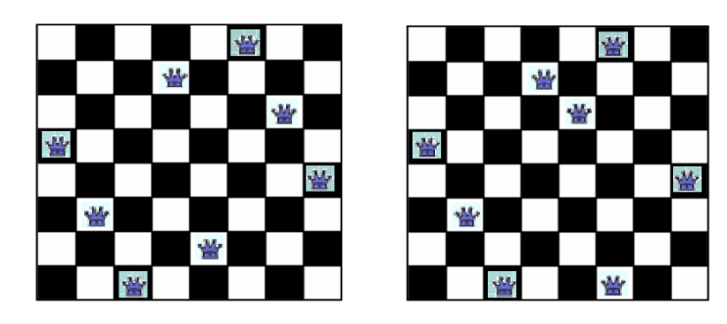
Problem Formulation:
- State Space: Any arrangement of k queens in the first k rows such that none are attacked
- Initial state: 0 queens on the board
- Successor function: Add a queen to the (k+1)th row so that none are attacked.
- Goal test: 8 queens on the board, none are attacked

Program:

import pprint

class grid:
def __init__(self, nfquen:int):
self.queens = nfquen
self.grid = [[' ' for i in range(self.queens)] for j in range(self.queens)]

def is_safe(self, posx, posy):
for row in range(self.queens):
if(self.grid[row][posy] == 'Q'):
return False
for col in range(self.queens):
if(self.grid[posx][col] == 'Q'):
return False

row = posx
col = posy
while(row>=0 and col>=0):
if(self.grid[row][col] == 'Q'):
return False
row -= 1
col -= 1
row = posx
col = posy
while(row<self.queens and col<self.queens):
if(self.grid[row][col] == 'Q'):
return False
row += 1
col += 1
row = posx
col = posy
while(row<self.queens and col>=0):
if(self.grid[row][col] == 'Q'):
return False
row += 1
col -= 1
row = posx
col = posy
while(row>=0 and col<self.queens):
if(self.grid[row][col] == 'Q'):
return False
row -= 1
col += 1

return True

def palce_queen(self, posx, posy):
self.grid[posx][posy] = 'Q'

def reset(self, posx, posy):
self.grid[posx][posy] = ' '

def show(self):
pprint.pprint(self.grid)

def nqueen(board, index, queens):
if(index >= queens):
return True

for col in range(queens):
if(board.is_safe(index, col)):
board.palce_queen(index, col)
if(nqueen(board, index+1, queens)):
return True
board.reset(index, col)
return False

nfqueen = int(input("Enter no. of Queen: "))
board = grid(nfqueen)

done = nqueen(board, 0, nfqueen)

if(done):
board.show()
else:
print("No solutions!");

Output:

